**Pizza Sales SQL Data Analysis**

**Using SSMS**

# KPI's

**1. Find the Total**

select sum(total_price) from pizza_sales;



**2. Find Average Order Value**

select sum(total_price)/COUNT(Distinct order_id) from pizza_sales;



**3. Find Total Pizza Sold**

select SUM(quantity) from pizza_sales;



**4. Total Order Placed**

select COUNT(Distinct order_id) from pizza_sales;



**5. Average Pizza Per Order; Using Cast to convert value to decimal point**

select cast(cast(sum(quantity) as Decimal(10,2))/

cast(COUNT(Distinct order_id) as Decimal(10,2)) as decimal(10,2))

from pizza_sales;



# **Charts**

**1. Total Number of Order on Daily Basis over the Period of time**

select DATENAME(DW, order_date) as order_day, COUNT(distinct order_id) as Total_orders

from pizza_sales

group by DATENAME(DW, order_date);

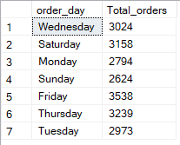

**2. Total Orders Placed Monthly over the Period of TIme**

select DATENAME(MONTH, order_date) as Month_Name,

COUNT(Distinct order_id) as Total_Orders

from pizza_sales

group by DATENAME(MONTH, order_date)

order by Total_Orders desc;

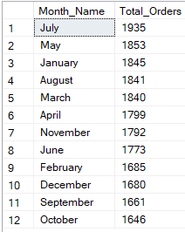

**3. Percentage of Sales with Pizza Category for month January**

select pizza_category, SUM(total_price) as Total_Sales,

Cast(sum(total_price)*100/(select sum(total_price) from pizza_sales)

as decimal (10,2)) as Percentage_sale

from pizza_sales

where MONTH(order_date) = 1

group by pizza_category;

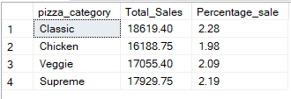

**4. Percentage of Sales with Pizza Size for 1st Quarter**

select pizza_size,

cast(SUM(total_price)*100/(select SUM(total_price) from pizza_sales

where DATEPART(QUARTER, order_date)=1)as Decimal(10,2)) as PCT

from pizza_sales

where Datepart(quarter, order_date) = 1

group by pizza_size

order by PCT;

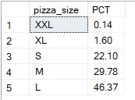

**5. Top 5 Best seller by Revenue,Quantity**

select Top 5 pizza_name,

SUM(total_price) as Total_Revenue

from pizza_sales

group by pizza_name

Order By Total_Revenue;

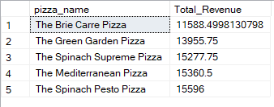

**6. Bottom 5 by Quantity**

select Top 5 pizza_name,

SUM(quantity) as Total_Quantity

from pizza_sales

group by pizza_name

Order By Total_Quantity ASC;

